2024 Artist Residency in the House of Lee Ungno
Open Call
The House of Lee Ungno, founded in November 2011 in Junggye-ri, Hongbuk-eup, Hongseong-gun, Chungcheongnam-do, honors the legacy of the Korean painter Goam Lee Ungno, who spent his career in France. Dedicated to commemorating his life and work, the institution has curated numerous exhibitions showcasing his art as well as modern and contemporary art.
Since its establishment in 2017, the Artist Residency in the House of Lee Ungno has welcomed 26 artists. The residency features two main sections: a traditional Korean hanok complex and a container complex. The hanok complex was reconstructed close to the artist’s house using dismantled materials from an old hanok near Joyangmun of Hongseong, while the container complex was repurposed from a former barn near the House of Lee Ungno. In honor of the artist’s 120th anniversary, the residency is delighted to invite international artists to participate in new initiatives.
The selected international artist will stay in the hanok complex specifically designed for the Artist Residency program from July to November, totaling approximately five months. The chosen artist will be encouraged to immerse themselves in creative pursuits and will be allocated spaces for both residing and creating, along with other essential amenities. Furthermore, a monthly fund of 400,000 KRW will be received to support their creative endeavors, as well as assistance for organizing the final exhibition. Please refer to the details below for more information.

1. Overview
- Number of Recruits: 1 person
- Recruitment Scope: All contemporary art disciplines
- Residency Period: From July 1, 2024 (Monday) to November 30, 2024 (Saturday)
(approximately 5 months in total)
- Eligibility: Non-Korean individuals aged 20 or older as of the date of recruitment announcement, speaker of English or Korean; Those who can commit to staying in the Residency for at least 15 days every month during the operating period of the Residency program.
- Supports Provided: Creative support stipend, allocated spaces for both residing and creating, cultural and artistic exploration program, final exhibition, etc.
- Residency: Artist Residency in the House of Lee Ungno at Hanok complex
(Workspace, living quarters, 2 restrooms, 1 multipurpose room, 1 kitchen)
※ It is essential to confirm information regarding the residency space such as living quarters and workspace.
- Address: 61-7 Ieeungno-ro, Hongbuk-eup, Hongseong-gun, Chungcheongnam-do
529 Junggye-ri, Hongbuk-eup, Hongseong-gun, Chungcheongnam-do)
- Selection Method: Selection through the 1st-phase document review >>> The 2nd-phase interview and Presentation assessment
- Application Period: From April 25, 2024 (Thursday) to May 9, 2024 (Thursday) (15 days), by 18:00 KST
- Required Documents: Application Form, Curriculum Vitae, Project Plan in Residency, Portfolio, Consent to the Collection and Use of Personal Information
- How to apply: Email application (goamhouse@korea.kr)
Format of email and attachment subject: "Artist Residency_First name_Surname"

- Detailed schedules
The schedules below are subject to change depending on institutional circumstances.

Process | Period | Remarks
Promotion and Application Period | April 25, 2024, to May 9, 2024  Application deadline: By 6:00 PM KST | Email application: goamhouse@korea.kr  Format of email and attachment subject  "Artist Residency_First name_Surname"
1^{st-}phase Document Review | May 14, 2024 (Scheduled)
1st-phase Document Result Announcement | May 16, 2024 (Scheduled) | The successful candidate will be announced on the homepage of the House
2nd-phase Interview and Presentation assessment | May 23, 2024 (Scheduled)  KST Scheduled between 9:00 AM and 6:00 PM KST | Interview and presentation in English
Announcement of the successful candidate | May 27, 2024 (Scheduled) | The result will be announced on the homepage of the House  If the successful candidate decides to withdraw from the residency, final acceptance may be determined based on the order of alternate runner-up candidates.
Residency period | July 1, 2024 (Mon) to July 3, 2024 (Wed) (Scheduled)

- Eligibility
- Non-Korean individuals aged 20 or older as of the date of recruitment announcement
- Speaker of English or Korean
- Those who can commit to staying in the Residency for at least 15 days every month during the operating period of the Residency program
- Those who have not participated in other Residencies during the same period as the House of Lee Ungno
- Artists actively engaged in pure art both domestically and internationally
- Organizations involved in educational, religious, or social activities are not allowed to apply.
- An artist who is eager to actively participate in the Residency program

- Applicants with eligibility restrictions
- Those who are currently under a labor contract
- Those who are currently enrolled in undergraduate or graduate programs
- Those who have prior Residency experience at the House of Lee Ungno
- Those who meet the criteria for entry and residence in South Korea without any disqualifying factors.

- Supports provided for the selected artist
- Creative support stipend (400,000 KRW monthly for five months)
- Space for creation (one room per person), living quarters (one room per person), kitchen, laundry room
- Cultural and artistic exploration program
- Final exhibition support fees
The selected artist shall be responsible for covering expenses such as airfare, travel insurance, medical insurance, visa issuance fees, and living expenses.

- How to apply
- Application period: April 24, 2024 (Wed) – May 8, 2024 (Wed): For 15 days
- How to apply: Email application (goamhouse@korea.kr)
- Steps to follow:
- Enter the Homepage of the House of Lee Ungno:
https://www.hongseong.go.kr/bbs/BBSMSTR_000000000765/list.do --> See the Announcement for Recruitment of International Artists for the 7th Residency (제7기 창작스튜디오 국제작가 모집공고) → Download the attachment and fill out the form to send the file via email)
OR
- Download the application form file through Google Drive :
https://drive.google.com/drive/folders/1rQVF4Kh9eex3pywSU_u0_BAlp4eiVvVp?usp=drive_link

- Format of email and attachment subject: “Artist Residency_First name_Surname”
- Make sure to scan all documents, except for videos, into a single PDF file and attach them.
- Inquiries: goamhouse@korea.kr

- Documents required to submit
No. | Item | Remarks
1 | Application form | Personal information, cover letter, presentation of artistic activities
2 | Curriculum Vitae | Write in a free format regarding your education background, domestic and international exhibition experiences, awards (maximum 1 page).
3 | Project plan in Residency | Describe your project plan during the Residency program, according to the provided format (maximum 800 words in English)
6 | Portfolio | - Maximum 10 pages according to the provided format  - For video works, maximum 2 pieces, each one within 3 minutes  - Applicants bear the responsibility for any disadvantages arising from portfolios malfunctioning or not conforming to the prescribed format, which may lead to their exclusion from the assessment process.
7 | Consent to the Collection and Use of Personal Information
8 | Copy of passport or Residence Card in Korea
9 | Documents or materials that can prove the applicant's active artistic activities | Graduation certificate as a major in fine arts (for major-related applicants only). Those who do not possess a fine arts major, documentation demonstrating significant involvement in relevant activities within the past three years, such as catalogs or brochures, is necessary.
- All documents must be prepared in English.
- The applicant is responsible for any disadvantages arising from the omission or delay of submitting
application documents, nonattendance at interviews, etc.

- Selection method
Assessment | Process | Period | Remarks
1st phase | Document assessment
2nd phase | Presentation | Within 10 minutes | - The assessment process will be conducted in English.  - During the video interview, assessment materials will be based on the portfolio submitted during the application process.
 | Q&A | Within 10 minutes
Candidates will be selected based on their combined scores from thorough evaluations, with the top scorers being prioritized.
Only applicants who successfully pass the first-phase assessments will receive instructions regarding the interview process for the second phase.

- Assessment Criteria and Outline:
- Applicant's creative competency and previous achievements in work
- Other requirements necessary for participation in the Residency program.

8. Obligations to comply with
- The Resident artist required to have valid health insurance coverage in South Korea. Unfortunately, we are unable to offer insurance.
- The Resident artist is required to spend at least 15 days per month at the Residency, actively participating in creative pursuits. In cases where prolonged absence is necessary for overseas exhibitions or other creative activities, the artist must inform and seek approval at least 10 days in advance.
- The Resident artist must actively cooperate with the associated programs of the House of Lee Ungno.
- The Resident artist shall be responsible for the usage costs of personal equipment as well as the costs associated with move-in and departure.
- Teaching or instructing individuals from outside the Residency premises is prohibited
- Occupancy of the Residency by anyone other than the assigned artist is not permitted.
- The Resident artist shall be responsible for both the upkeep and cleanliness of the individual studio and all shared facilities (the kitchen, seminar room, and outdoor spaces). This responsibility ensures the pleasant and safe management of the facility through conscientious usage.
- Any other matters will be operated pursuant to the management and operation regulations of the Artist Residency in the House of Lee Ungno located at Hongseong-gun.

9. Important remarks
- Submitted documents and materials will not be returned.
- Applications with documents differing from the prescribed format may be excluded from assessment processes.
- The applicant is responsible for any disadvantages arising from the omission or delay of submitting
application documents, nonattendance at interviews, etc.
- If the information provided in the submitted documents is found to be false, the applicant may face exclusion from the assessment processes. Furthermore, even after the announcement of final successful candidates or contract signing, acceptance may be retracted, and the residency contract terminated.
- Assessment schedules and move-in dates for the Residency may be subject to change depending on the circumstances of the House.
- If the chosen final candidate decides to withdraw from the Residency, the subsequent successful candidate will be selected in order of highest scores, without additional announcements.
- The Program-related contract will be prepared in English.

10. Other details
- Before submitting your application for the Program, make sure to thoroughly examine the details regarding the Residency space.
- In case of the following circumstances, there may be disadvantages for the final chosen artist such as cancellation of residency:
- In case of any omitted, delayed, intentionally omitted, or falsified information in the submitted documents.
- If there are alterations to the submission format, surpassing file size restrictions, or if document cannot be verified.
- If personal timetables hinder the smooth execution of project activities.
- If there are significant health issues, such as severe infectious diseases or health complications impeding participation in the program.

11. Guide to the Residency studio (73㎡)
Outer appearance
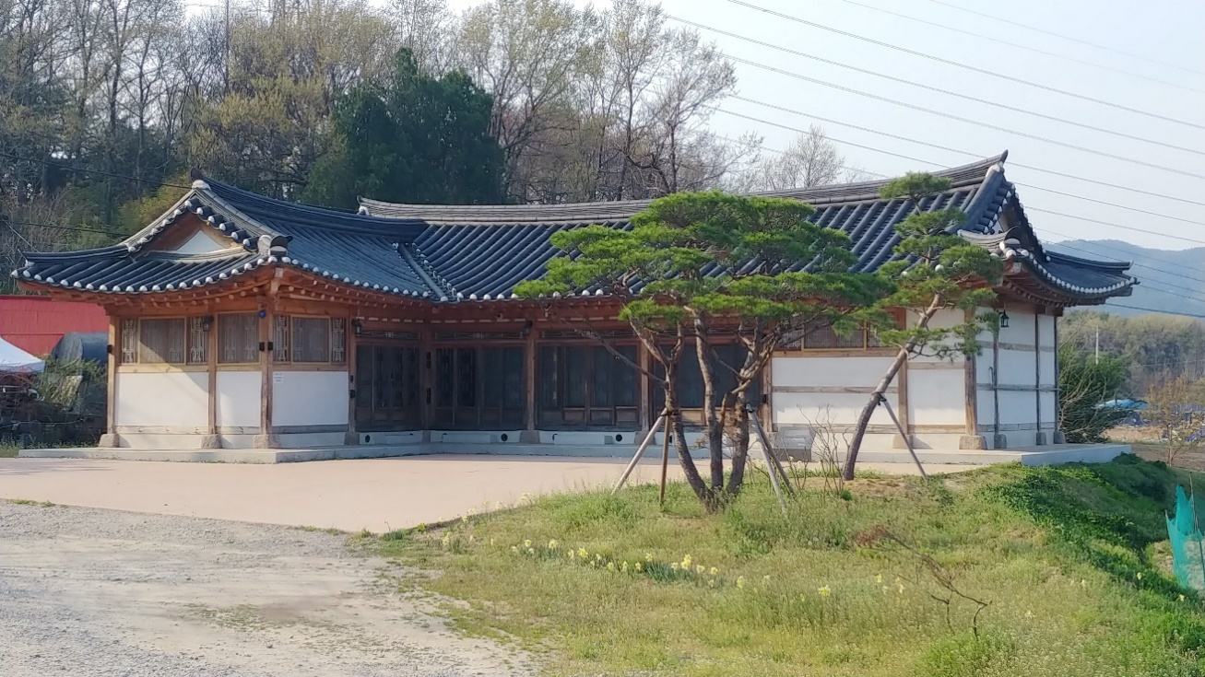
Inside
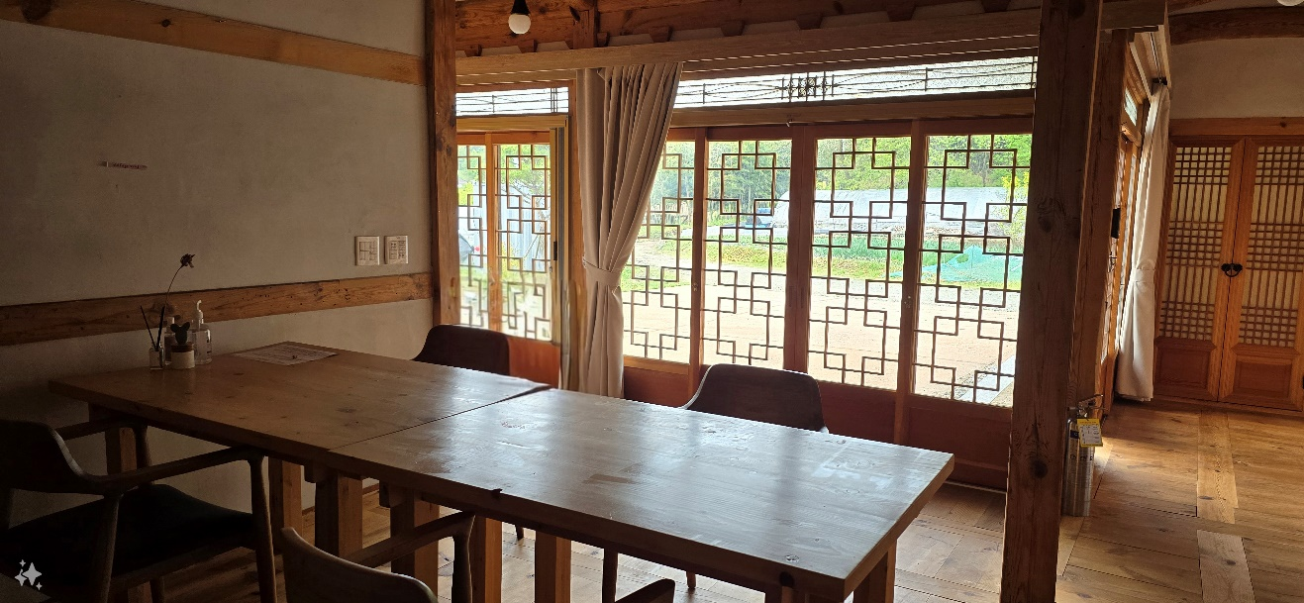
Studio area: Approx. 9.7㎡
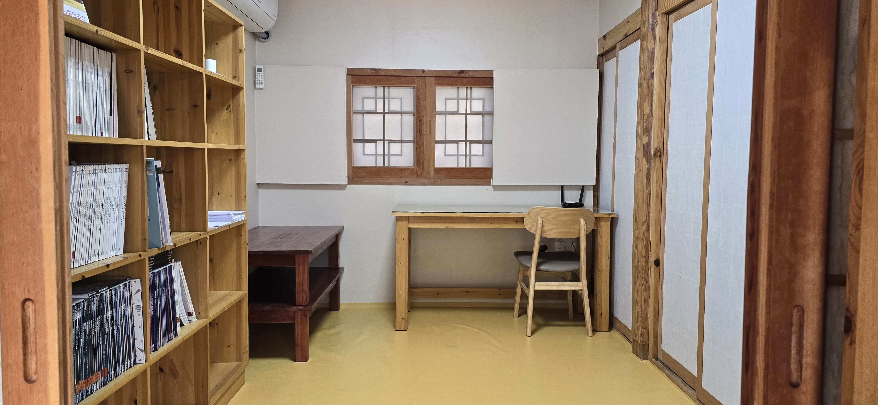

Living quarters: Approx. 9.7㎡
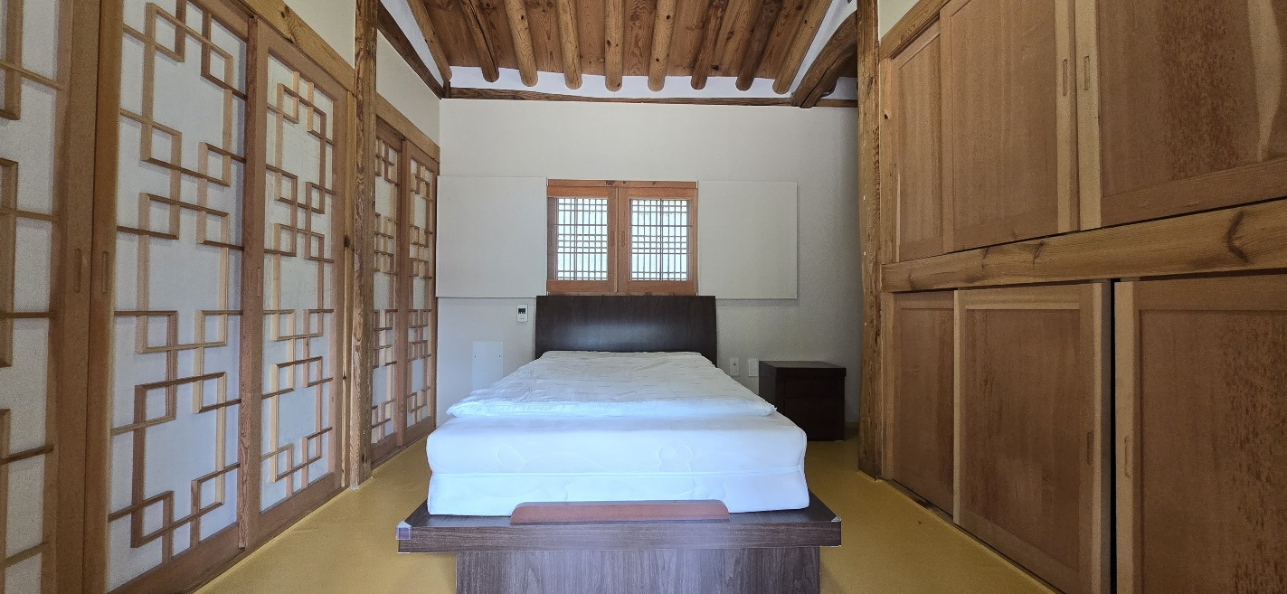

2024 Artist Residency in the House of Lee Ungno
Application Form
Please fill in the application form in English, gather all documents in one .pdf then send it to the mail address (goamhouse@korea.kr)
The title of mail and the file must be “Artist Residency_First name_Surname”
Primary field
First name |  | Surname
Date of birth |  | Nationality/Country
Address
Postal code/City
Gender
Email |  | Mobile
Website/Instagram
Spoken language
Summary of your work | Max 500 words
Motivation of applying our Residency | (max 300 words)
2024 Artist Residency in the House of Lee Ungno
Project Plan in Residency
First name |  | Surname
Max 800 words.

2024 Artist Residency in the House of Lee Ungno
Portfolio
 |  | Number
First name |  | Surname
Caption | Title, material, size, year

2024 Artist Residency in the House of Lee Ungno
Consent to the Collection and Use of Personal Information

I hereby consent to the collection, utilization, and provision of my personal information as outlined below, pursuant to Article 15 of the Act on Personal Information Protection. This is for the purpose of evaluating, deliberating, distributing information, promoting, and managing the "7th International Artist Residency in the House of Lee Ungno 2024" program's Open Call in 2024.
1. Purpose of Collection and Use of Personal Information
- Personal information will be gathered solely for the purpose of collecting information from
applicants for the “7th International Artist Residency in the House of Lee Ungno 2024" and will not be utilized for any other purposes beyond those specified below.
- Personal information will be utilized to facilitate the operation, assessment, and deliberation processes of the contest.
- Personal information will be utilized to deliver contest-related information and establish communication channels.
- Personal information will be used for promotion and operation, etc.
2. Items of Personal Information to Collect
- Applicant's name, identity number, date of birth, address, contact information, email, images and videos of the work, etc.
- Applicant's educational background, experiences related to exhibition and project activities, materials prepared and submitted by the applicant, etc.
3. Period of Retention, Use and Provision of Personal Information, etc.
- This submitted documents are intended for the selection of the artist for the Residency until the end of this project.
4. Right to Refuse Consent and Disadvantages Resulting from Refusal
- I hereby acknowledge that I have the right to refuse the collection of personal information.
- Disadvantages Resulting from Refusal: Restrictions on participation in the contests and programs due to insufficient basic information collected
※ I hereby acknowledge the processing of my personal information and fully understand and consent to the terms stated above.
■ Do you consent to the collection and use of your personal information? □ Yes / □ No
Date: _______________________

Name: (Signature/Seal)
Date of Birth:
To the Governor of Hongseong-gun

